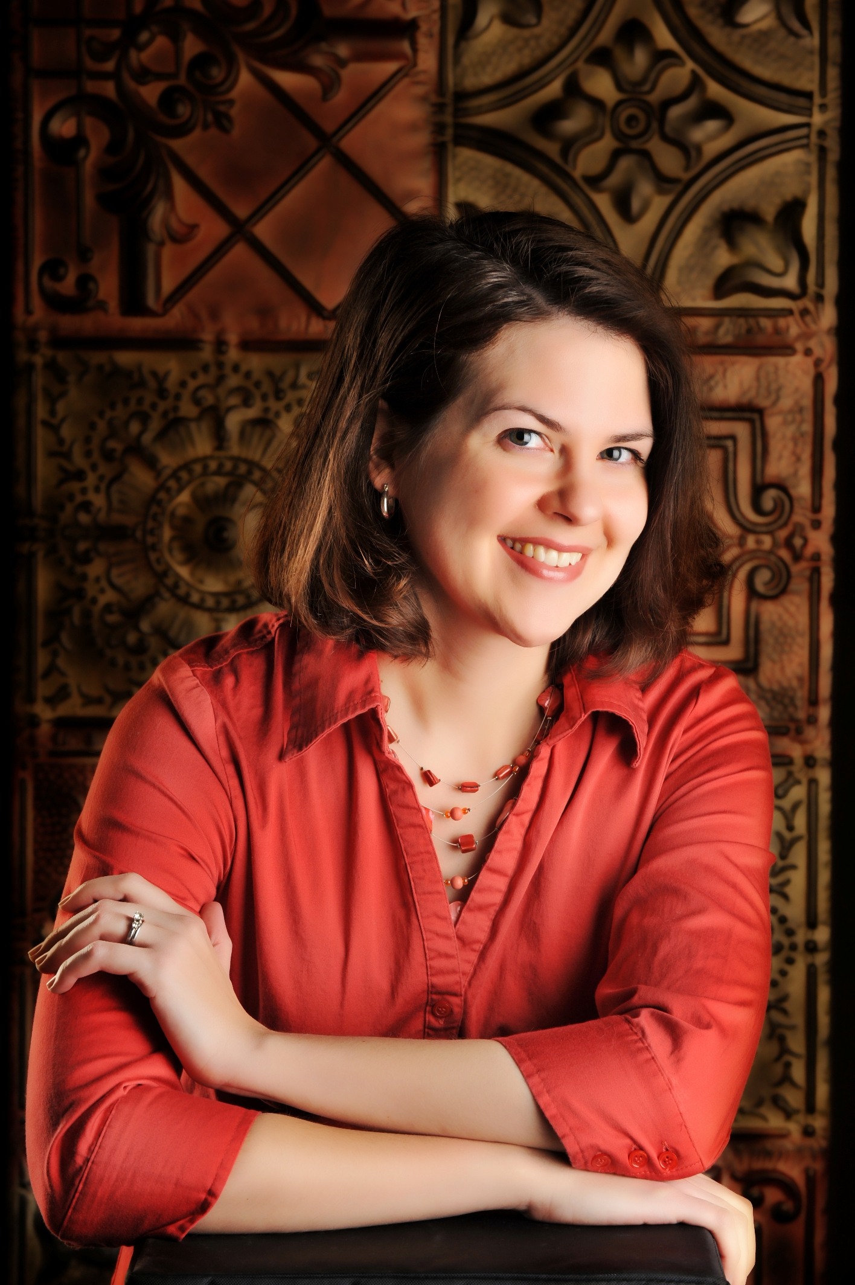
E-mail: jocelyn@jocelyngreen.com
Web Site: www.jocelyngreen.com

Literary Inquiries:
Tim Beals, Credo Communications,
timbeals@credocommunications.net

Jocelyn Green is the award-winning author of ten books, including fiction and nonfiction. A former military wife herself, she offers encouragement and hope to military wives worldwide through her Faith Deployed books and The 5 Love Languages Military Edition, which she co-authored with best-selling author Dr. Gary Chapman. Her Civil War novels, inspired by real heroines on America’s home front, are marked by their historical integrity and gritty inspiration.

Jocelyn graduated from Taylor University in Upland, Indiana, with a B.A. in English, concentration in writing. She is an active member of the Christian Authors Network, the Advanced Writers and Speakers Association, American Christian Fiction Writers, and the Military Writers Society of America.

She loves Mexican food, Broadway musicals, Toblerone chocolate bars, the color red, and reading on her patio. Jocelyn lives with her husband Rob and two small children in Cedar Falls, Iowa. Visit her at www.jocelyngreen.com.

Media Highlights
Radio:
Jocelyn has been a guest on the Focus on the Family Jim Daly Show, Building Relationships with Gary Chapman, Midday Connection, Chris Fabry Live, Family Life Today, and more.
Books:
In addition to contributions to the books Stories Around the Table, and 1001 Things to Love About Military Life, and Heroes at Home, she has authored the following book titles:

- Spy of Richmond (RiverNorth Fiction, 2015)
- Yankee in Atlanta ((RiverNorth Fiction, 2014)
- Widow of Gettysburg (RiverNorth Fiction, 2013)
- The 5 Love Languages Military Edition with Dr. Gary Chapman (Northfield Publishing, 2013)
- Wedded to War (RiverNorth Fiction, 2012)
- Military Wives’ New Testament with Psalms & Proverbs (HarperCollins/Zondervan, 2012)
- Stories of Faith and Courage from the Home Front with Karen Whiting (AMG Publishers, 2012)
- Faith Deployed . . . Again: More Daily Encouragement for Military Wives (Moody Publishers, 2011)
- Stories of Faith and Courage from the War in Iraq & Afghanistan with Jane Cook and John Croushorn AMG Publishers, 2009)
- Faith Deployed: Daily Encouragement for Military Wives (Moody Publishers, 2008)

Magazine Work includes:
- Christianity Today
- Thriving Family
- Publix FamilyStyle
- Nestle Very Best Kids
- Today’s Christian
- Christian Communicator
- Command Magazine
- Today’s Pentecostal Evangel
- Ignite Your Faith
- BestSemester Magazine
- Baptist Bulletin
- InSite
- EFCA Today

Awards:
- 2014 Silver Medal, Military Writers Society of America (historical fiction category): Widow of Gettysburg
- 2013 Gold Medal, Military Writers Society of America (historical fiction category): Wedded to War
- 2013 Gold Medal, Military Writers Society of America (spiritual category):Stories of Faith and Courage from the Home Front
- 2013 Christy Award Finalist (First Novel and Historical categories): Wedded to War
- 2013 Inspirational Readers Choice Award (women’s fiction), Third Place:Wedded to War
- 2013 Golden Scroll Award (nonfiction category), Advanced Writers & Speakers Association: Stories of Faith and Courage on the Home Front
- 2012 Gold Medal Winner, Branson Stars & Flags Awards (Inspirational category): Faith Deployed…Again
- 2012 Silver Medal Winner, Military Writers Society of America (Spiritual/Religious category): Faith Deployed…Again
- 2012 Selah Award (Inspiration & Gift category): Faith Deployed…Again
- 2010 Gold Medal Winner, Military Writers Society of America (Inspirational category): Stories of Faith and Courage from the War in Iraq & Afghanistan
- 2010 Bronze Medal Winner, Military Writers Society of America (Inspirational category): Faith Deployed
- 2010 Silver Medal Winner, Branson Stars & Flags Book Awards (Inspirational category): Stories of Faith and Courage from the War in Iraq & Afghanistan
- 2010 Bronze Medal Winner, Branson Stars & Flags Book Awards (Inspirational category): Faith Deployed
- 2010 First Place, Higher Goals in Christian Journalism Award (Freelance Article category) for “Married to the Military” in Pentecostal Evangel
- 2009 Third Place, Higher Goals Award (Best Blog category) for the blog Faith Deployed: Spiritual Support for Military Wives

Speaking:
- Has presented on Civil War topics in Gettysburg, Pennsylvania; Atlanta, Georgia; and various Iowa locations
- Keynote speaker at military events from Michigan to Virginia
- Workshop leader at the Protestant Women of the Chapel International Conference in Dallas, Texas
- Has taught writing and/or marketing at:
  - Evangelical Press Association Conventions (Colorado Springs, Dallas, and Indianapolis)
  - All-Iowa Writers Conference in Iowa City
  - Breathe Christian Writers Conference in Grand Rapids, Michigan
  - Cedar Falls Christian Writers Workshop in Cedar Falls, Iowa
  - Iowa Reading Association Conference in Ames, Iowa

See Next Page for Blank Speaking Event Worksheet

Speaking Event Worksheet
Jocelyn Green

Name:__________________________________________________________________
Organization____________________________________________________________

Address________________________________________________________________

City, State, Zip Code _____________________________________________________

Phone Number_________________________________
Email: _______________________________________________________________
Location of Event: _____________________________________________________
Number of Presentations and Time Length of each:__________________________
Date(s) you would like Jocelyn for your event?:_______________________________
Number of Days (Including Travel Days) __________________________________
Estimated Number of Attendees ___________________________________________
Type of Event (Keynote, Conference, Retreat, Banquet, Workshop, Etc)
______________________________________________________________________
Is there a projector, screen, and computer available on location? _______________
Is a book table allowed? (yes or no) ____________
Percentage required on book table? (yes or no) _______
If “yes,” what percentage? ________________
What is your budget for the speaker? _____________________________________________
Thank you for your interest! Please email this completed form to speaking@jocelyngreen.com.

